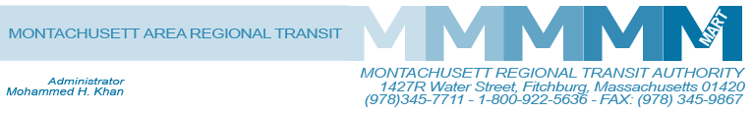

Posted 101/15/2014 at 11:45 am by JAV

MEETING OF THE MART ADVISORY BOARD
MART Maintenance Facility
1427R Water Street
Fitchburg, MA 01420

Tuesday, October 21, 2014
10:30 A.M.

Agenda

- Call to Order
- General Comments
- Approval of April 30, 2014, May 27, 2014 and June 23, 2014 Minutes
RESOLUTION 736- BE IT RESOLVED that the Advisory Board of the Montachusett Regional Transit Authority approves the April 30, 2014 minutes as presented.
RESOLUTION 737- BE IT RESOLVED that the Advisory Board of the Montachusett Regional Transit Authority approves the May 27, 2014 minutes as presented.
RESOLUTION 738- BE IT RESOLVED that the Advisory Board of the Montachusett Regional Transit Authority approves the June 23, 2014 minutes as presented.
- Financial Matters
A. Status of State Funding
B. Status of Federal Funding
C. Audit FY2014-Presentation by Stowe & Degon
D. Status on Joining State Pension and GIC

V. Administrative Matters
A. Request for Additional Fixed Route Bus/Van Service in Lunenburg
B. Possible Commuter Bus/Van Service in Littleton, Boxborough and Devens to Coordinate with MBTA’s Commuter Rail Service
C. Fitchburg Rider Non-Voting Member- Pauline Clark
VI. Capital Equipment/Facilities
- Improvement to the Commuter Rail Corridor between Fitchburg and Boston
- Wachusett Commuter Rail Extension Project – Station, Parking and Layover Facilities
C. Parking Improvement at Ayer-Rail Trail Facility-Transfer of designated property to MART from its owner
VII. Operational Services and Status Reports
A. MART Operation Status on Revenue and Ridership
1. Fitchburg/Leominster
2. Gardner and Mount Wachusett Community College
3. Athol MTG Services/Athol COA
VIII. HST and Other Brokerage Status Reports

IX. Other Business

X. Adjournment

C: City and Town Clerks: Please post this notice pursuant to MA General Laws Chapter 30A,
Sections 18-25.

